**P2 -** Demonstrate the use of event driven tools and techniques **and M2 -** Give reasons for the tools and techniques used in the production of an event driven application **Part 2**

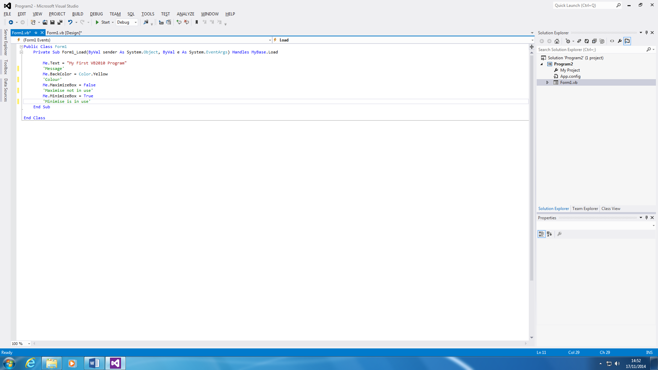**Background Colour**

Each program is designed for it to be different. Each line is designed to do different thing. The first line of the code only shows what it will say at the top of it. If you want to change it, you can whatever you want it to say between the speech marks. The second line shows the background colour. I put yellow, but you can change whatever colour you like. The both two bottoms lines are for to maximise the program and the last is to minimise. I put the maximum box false, to ensure that the user cannot enlarge the program using the maximum program. I put the minimise true for the program to minimise.

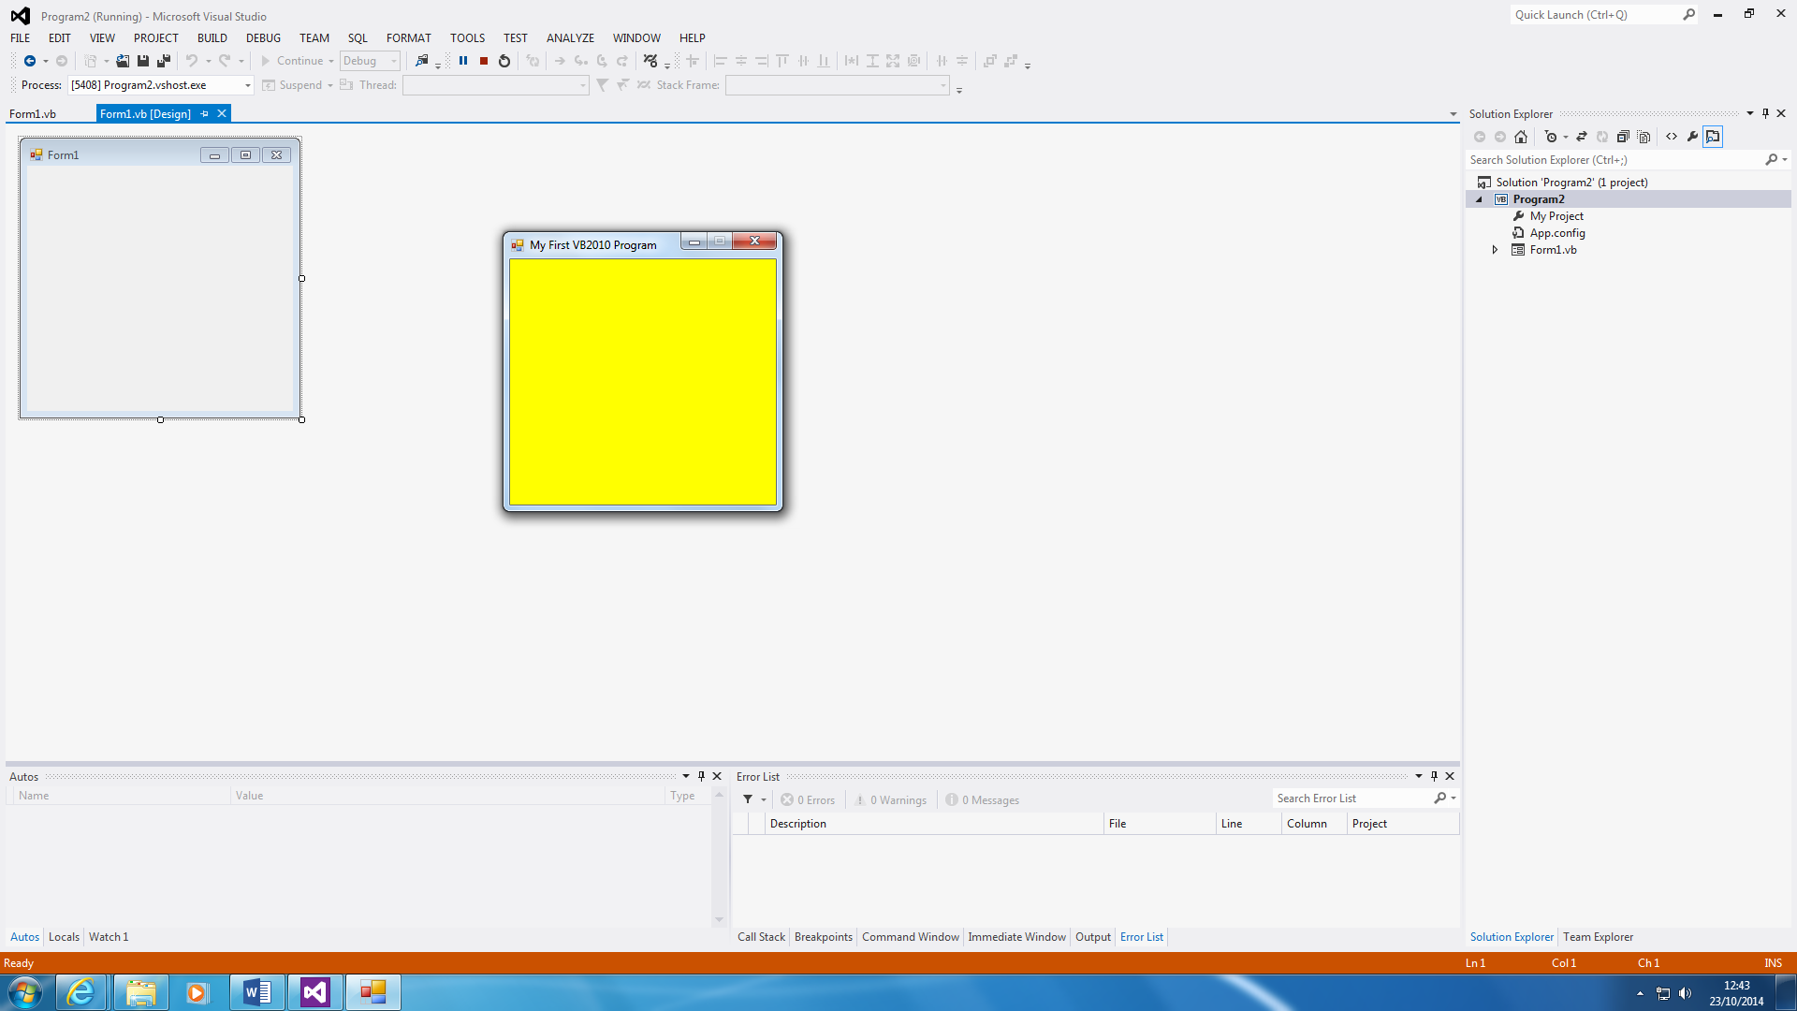

This is how the program has been presented. As you can see, the maximum button cannot be used at the start. You can use the mouse to minimise the program. The program only shows the colour yellow. I only done this, but you can make it to a lot more.

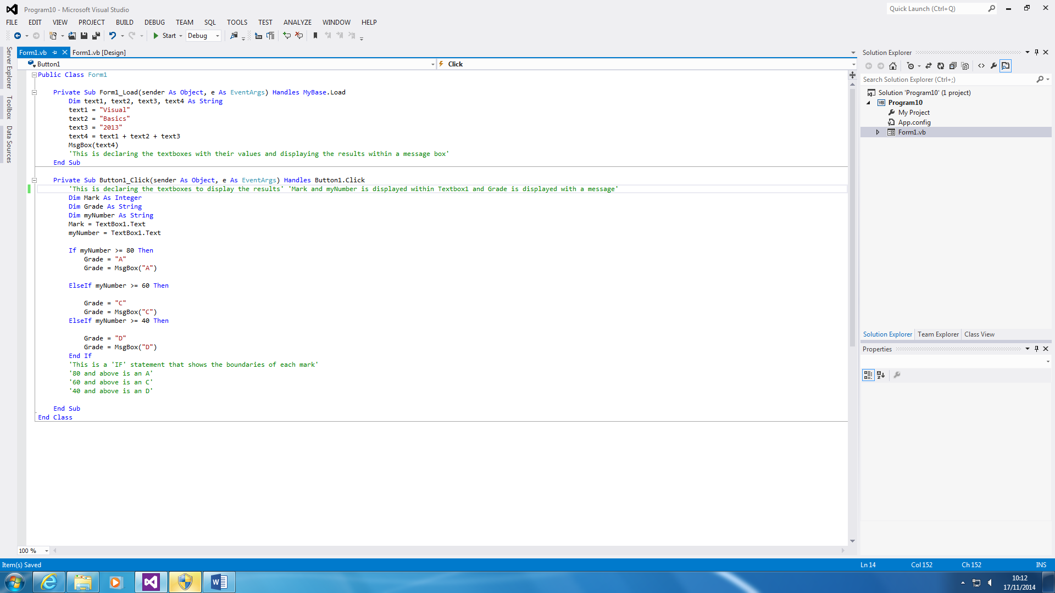**IF Statement**

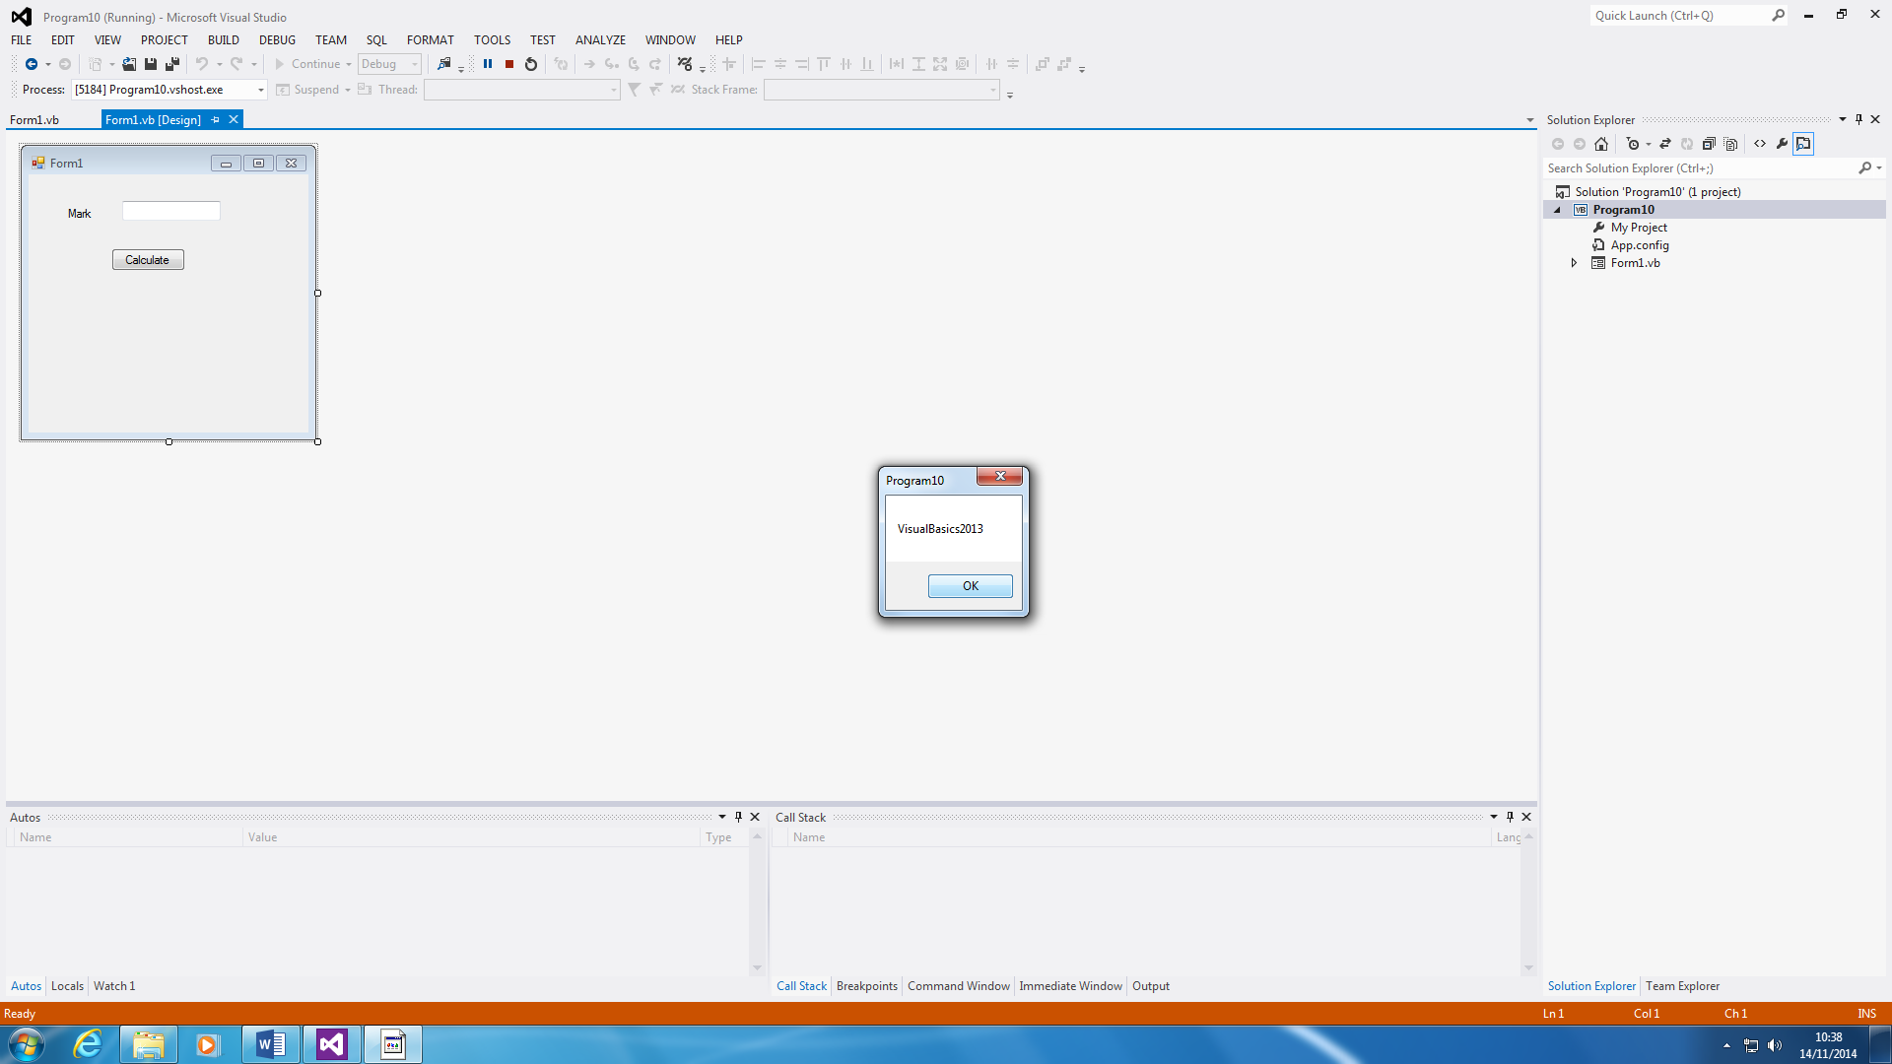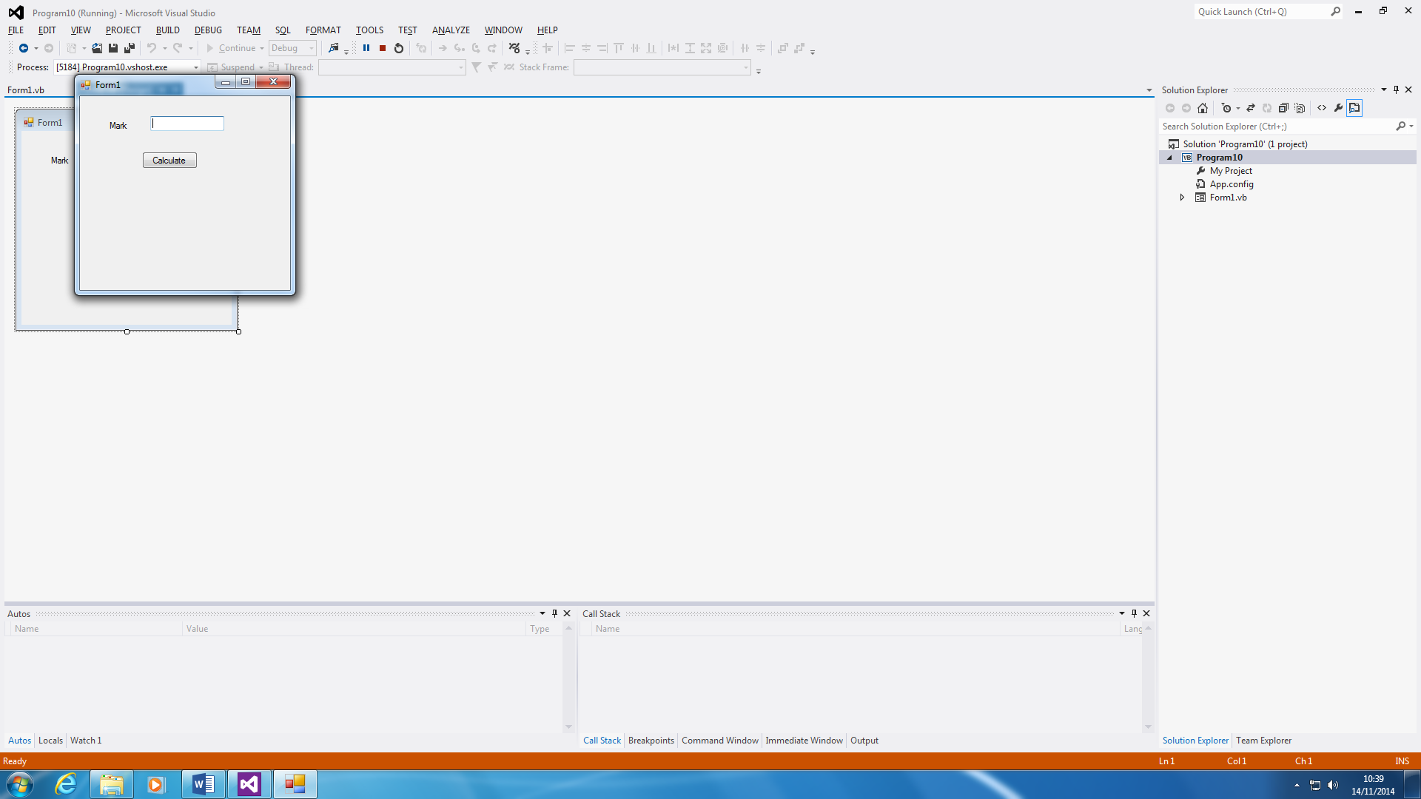

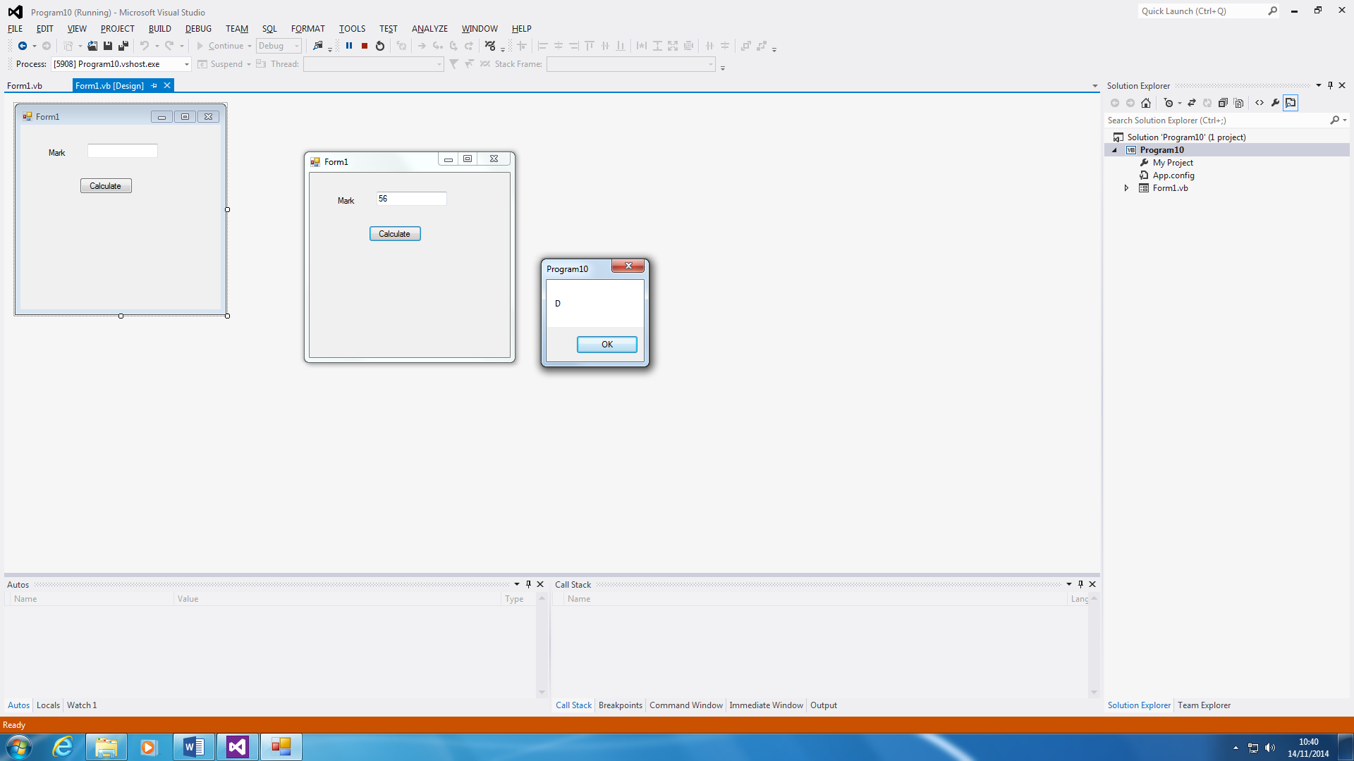

This program can be designed to calculate a grade for a specific paper. The grade boundaries are 80 and above is an A; 60 above is a C; and 40 above is a D. First, a message appears for VisualBasics2013, and then you put in your grade, as shown above. Whatever the mark is e.g. 56, it will grade it e.g. D.

**DO UNTIL and DO**

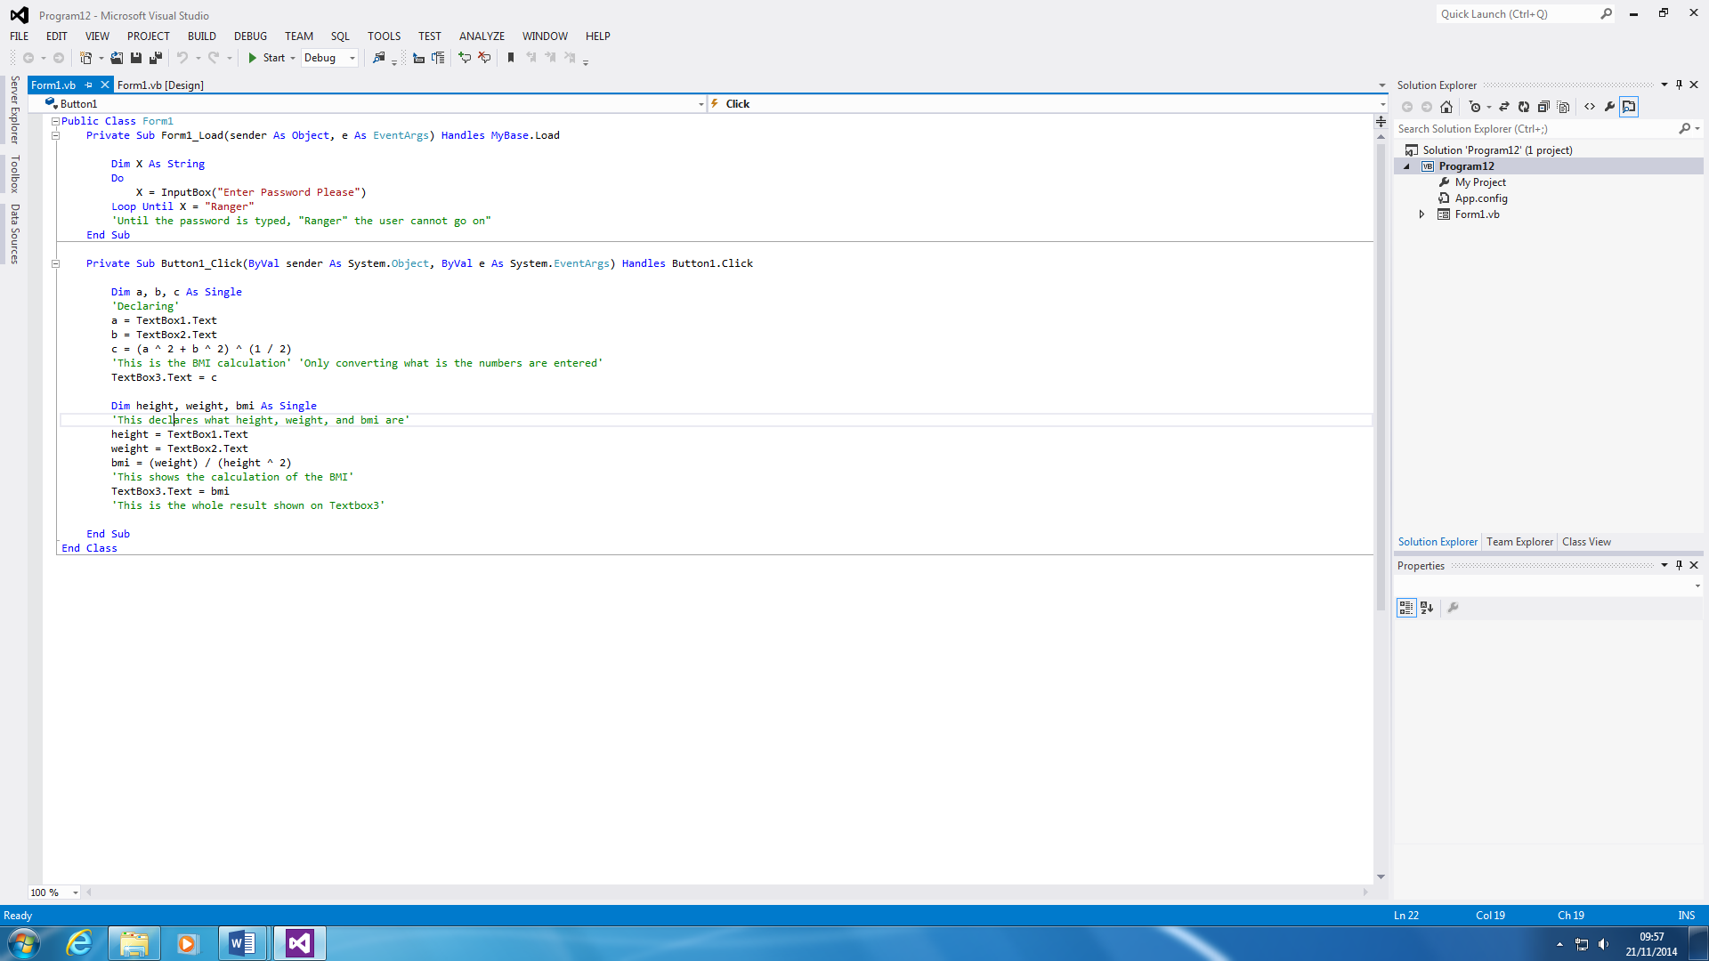

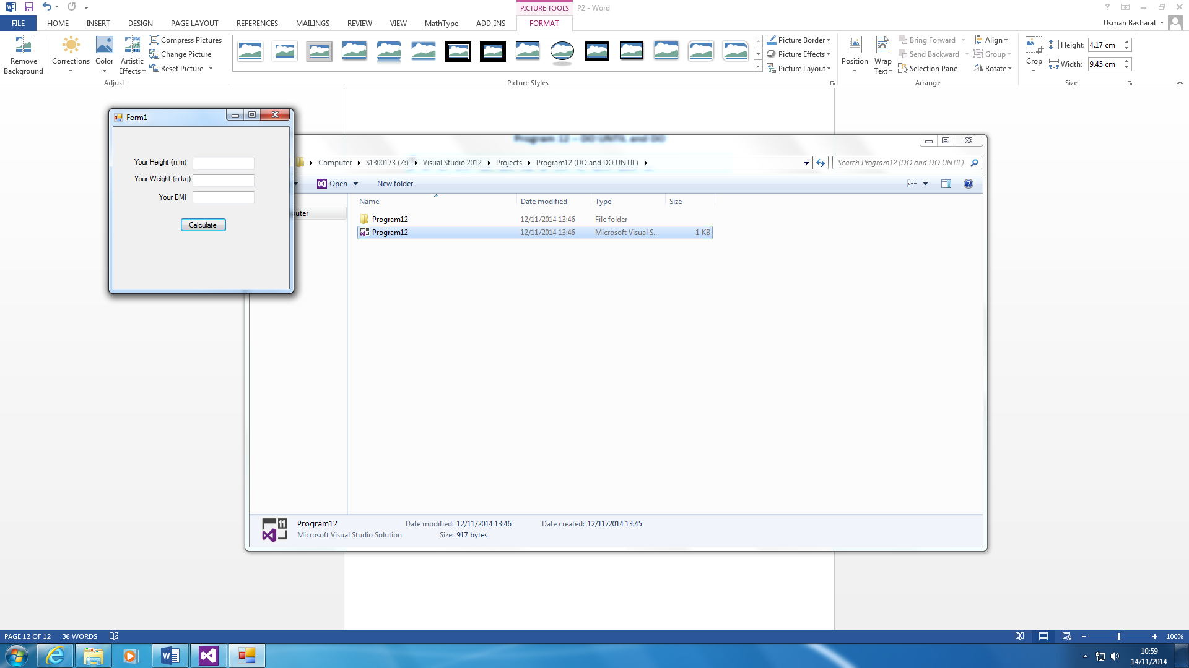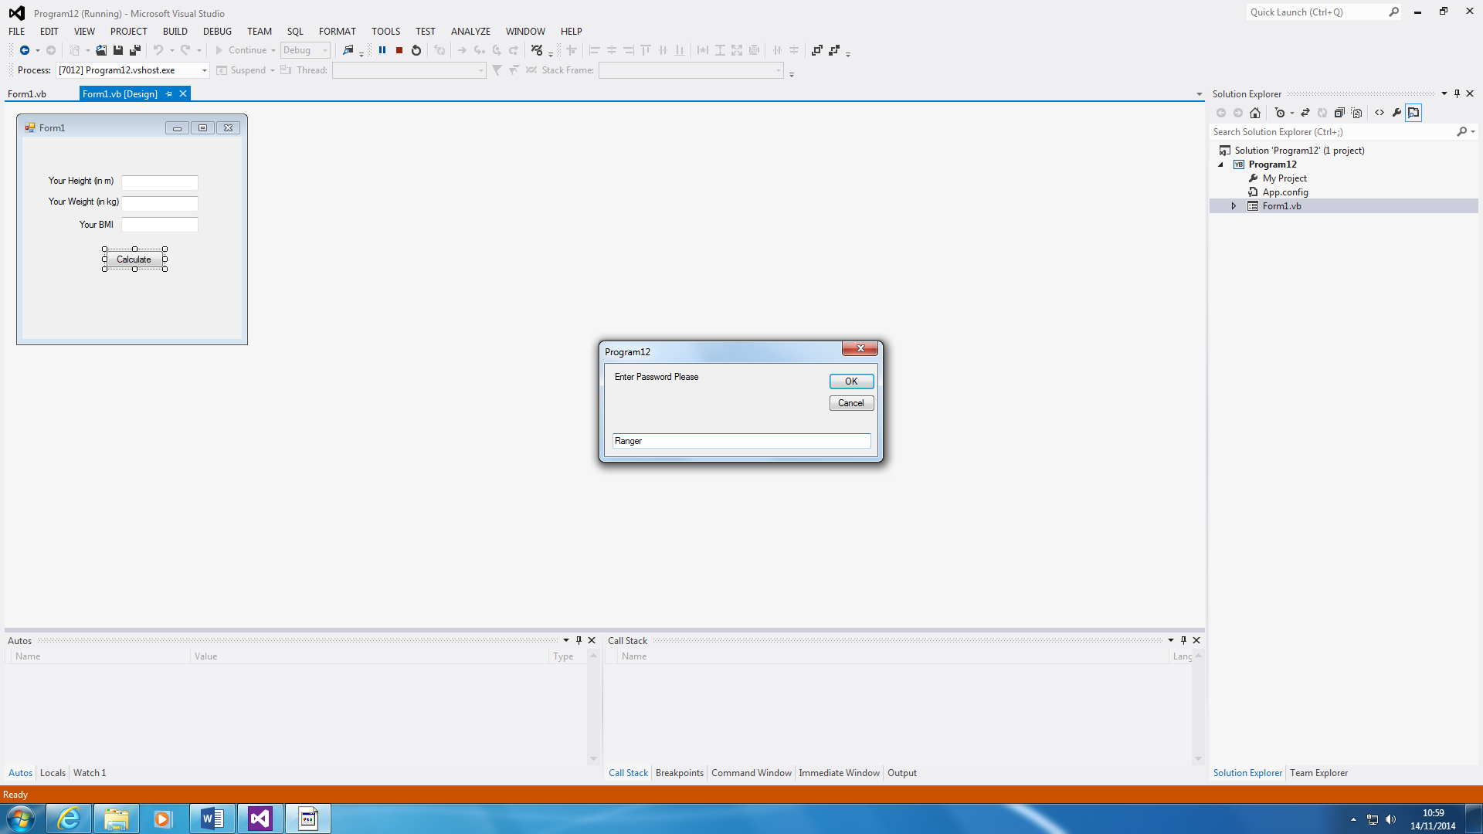

Before anything can happen, you have to type in the password. The main point of this is to keep a password. If the user wants to sign into something, you have to type in a password, until the user has entered it. The password is Ranger, and you can change it within the code.

It will keep repeating until the user has typed in the correct password.

This is the BMI calculation. The purpose of using this program is to calculate a person’s BMI. If a person is 18 to 25, it is normal. If it is above or below, they are obese or underweight. All you do for this program is to enter the details of yourself as shown🡪.

It will calculate itself.

**Key Press**

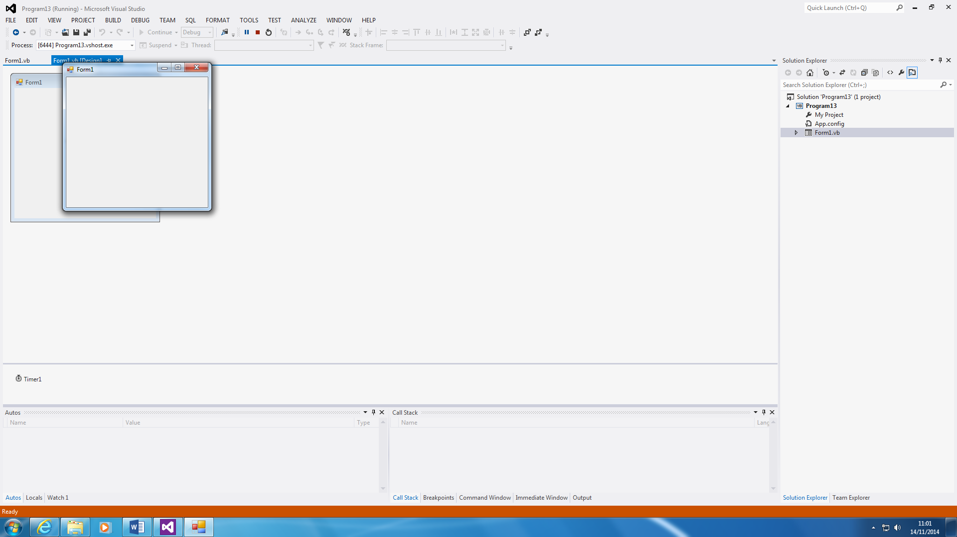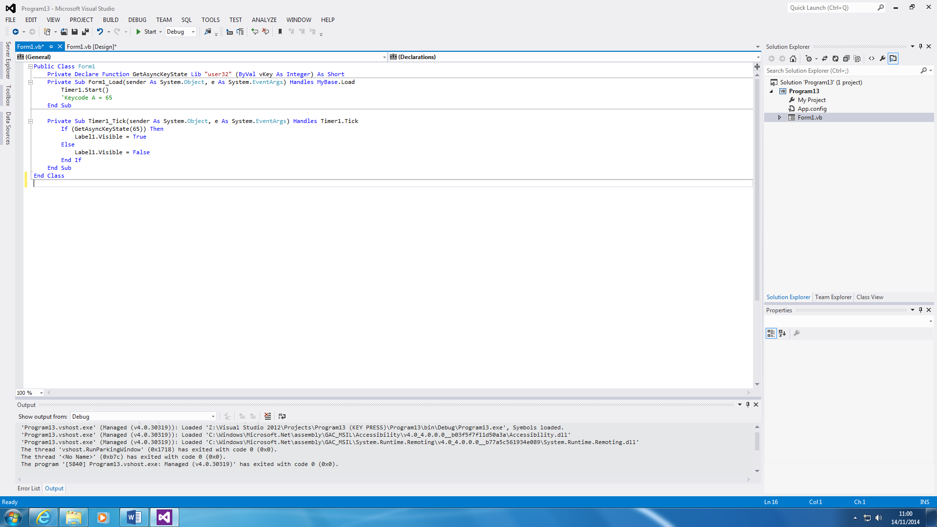

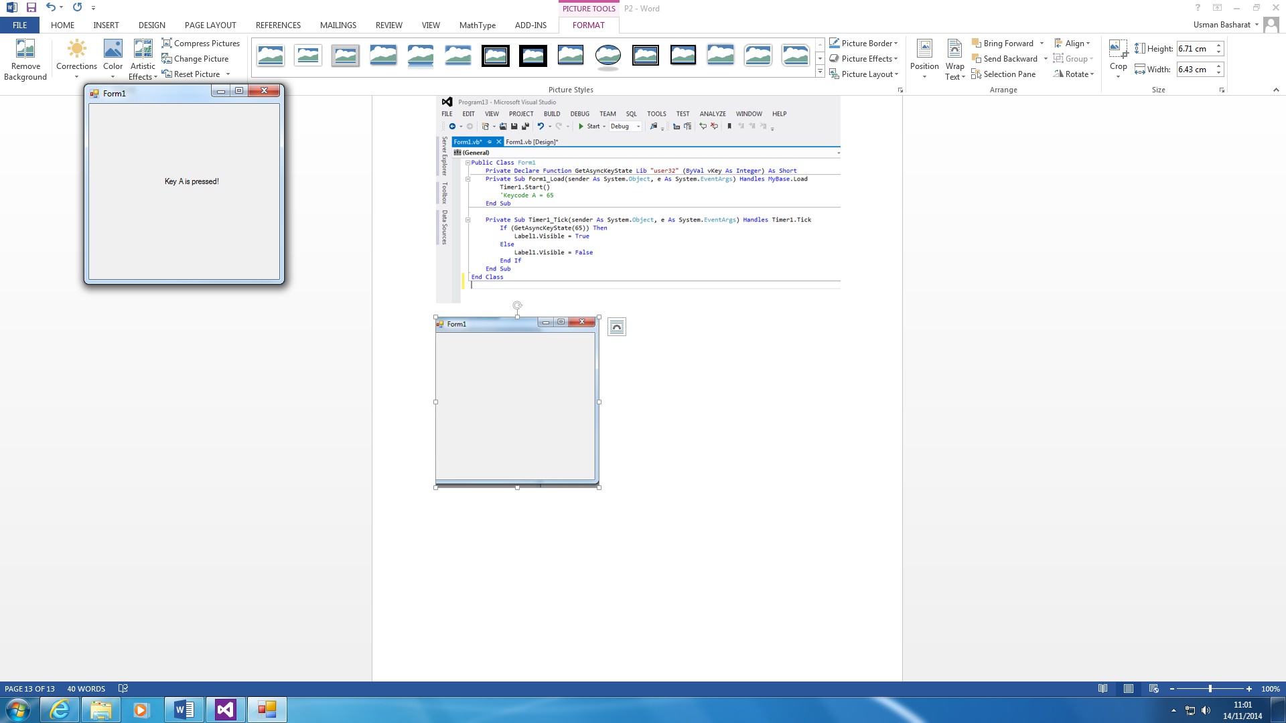

This program is very basic. All it does is it recognises that A is pressed. As soon as the key ‘A’ is pressed, a message will appear showing that it has been recognised. This message will not appear, until key ‘A’ is pressed.

**Declaring Constant**

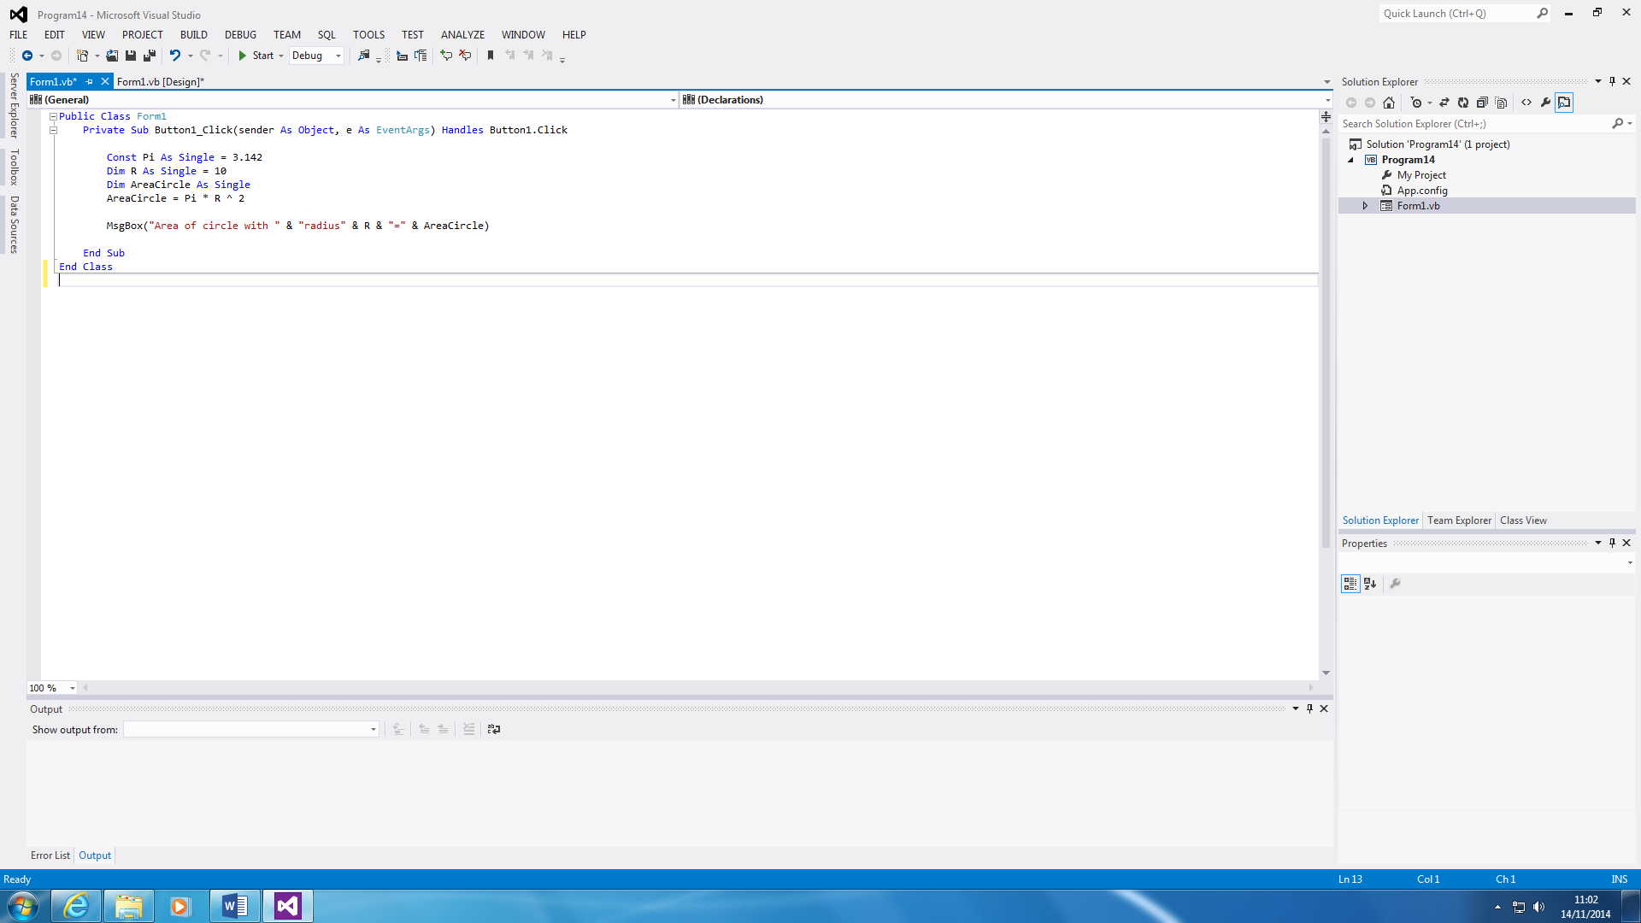

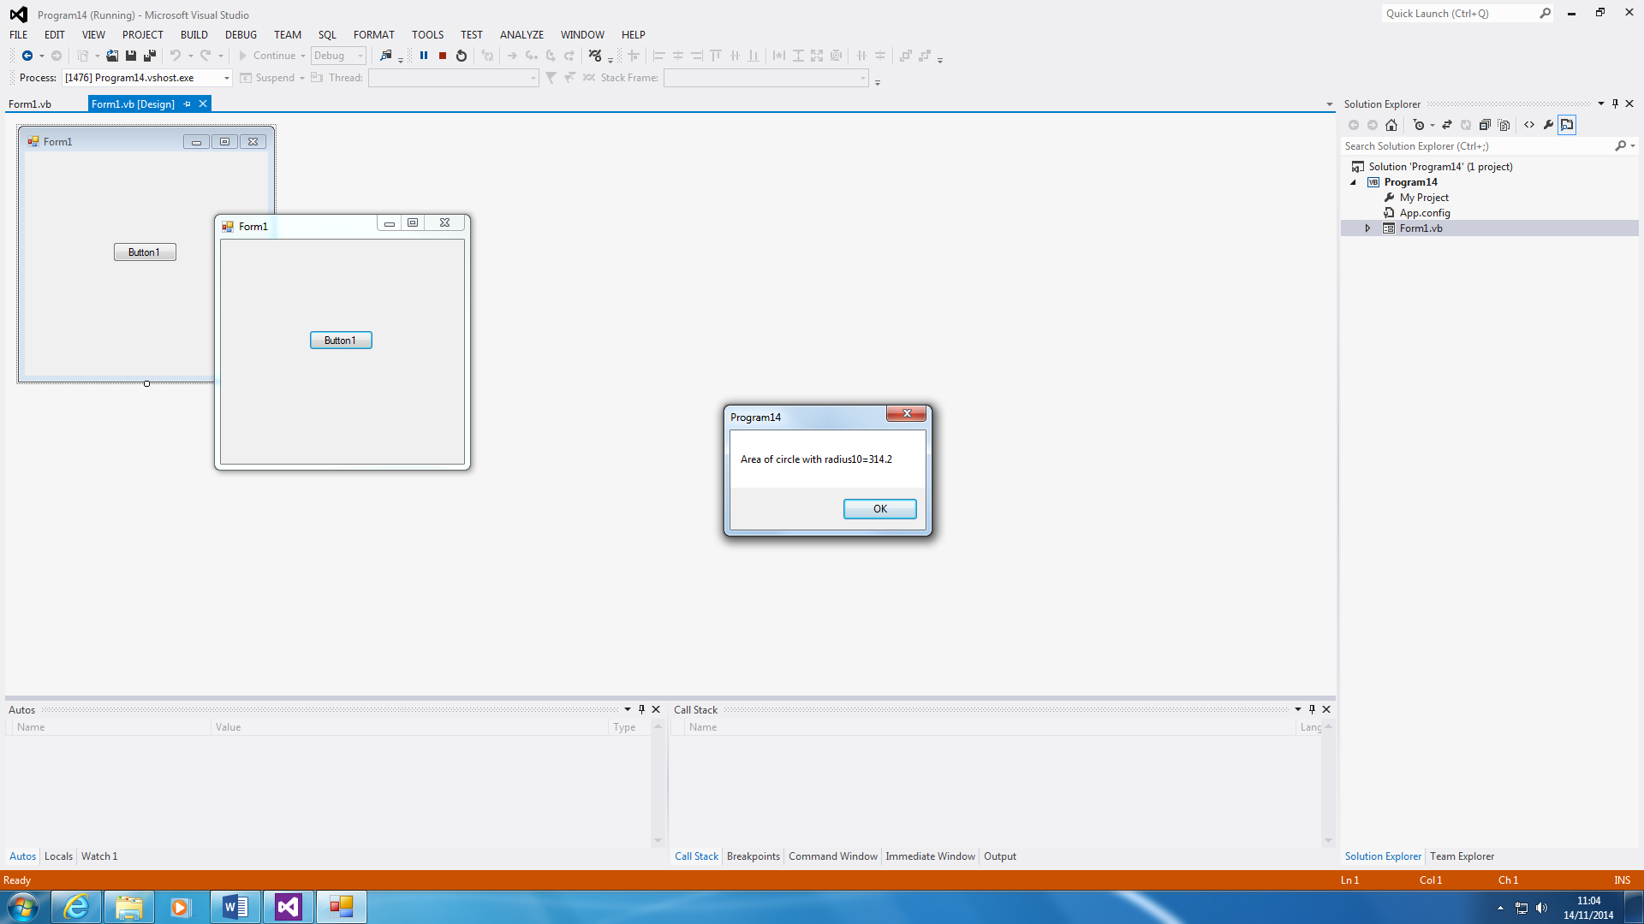

This seems simple, but it has been declared differently. Constant and Dim is the same, as in both are two declaring something, but they are used differently. Constant is used to declare a value that is very long e.g.3.14159265F. This is long, and it will take up space. You can just declare it by using Const. In this case, PI and R is used. PI is used for the π and R is used for Radius. The main aim is to find the area of the circle with the radius being 10. It shows the answer and it is 314.2.

**DO WHILE**

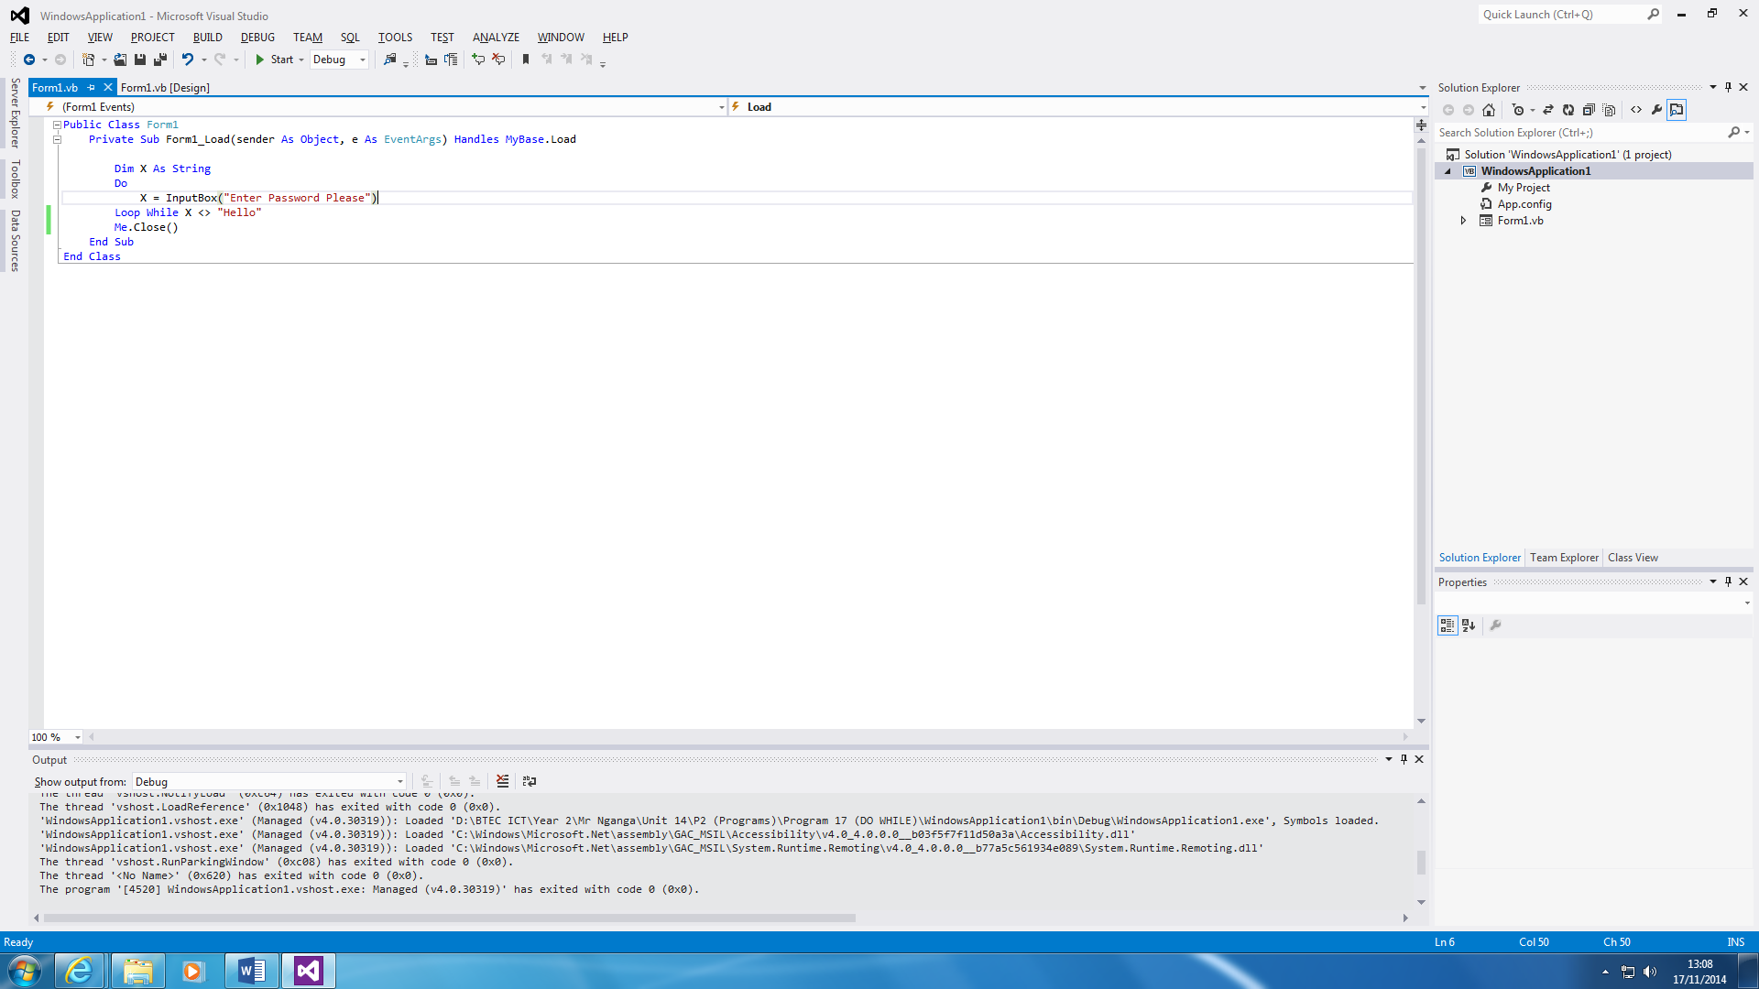

This program is similar to the other program that is made, but it has a ‘DO WHILE’ loop right at the end of it. This is a password program, and you have to type in a specific-coded password for you to release. The password is ‘Hello’, and the user can only continue if the password, ‘Hello’ has been entered. You cannot move, or close the screen until it has been complete.

‘Me.Close ()’ tells us that once the password has been entered, it close the application. This show us you can only type in the password, and it is complete.

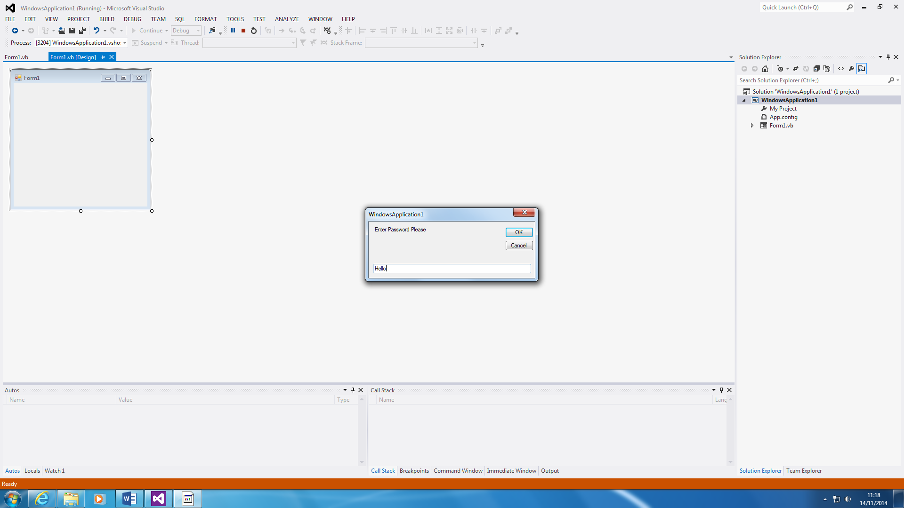

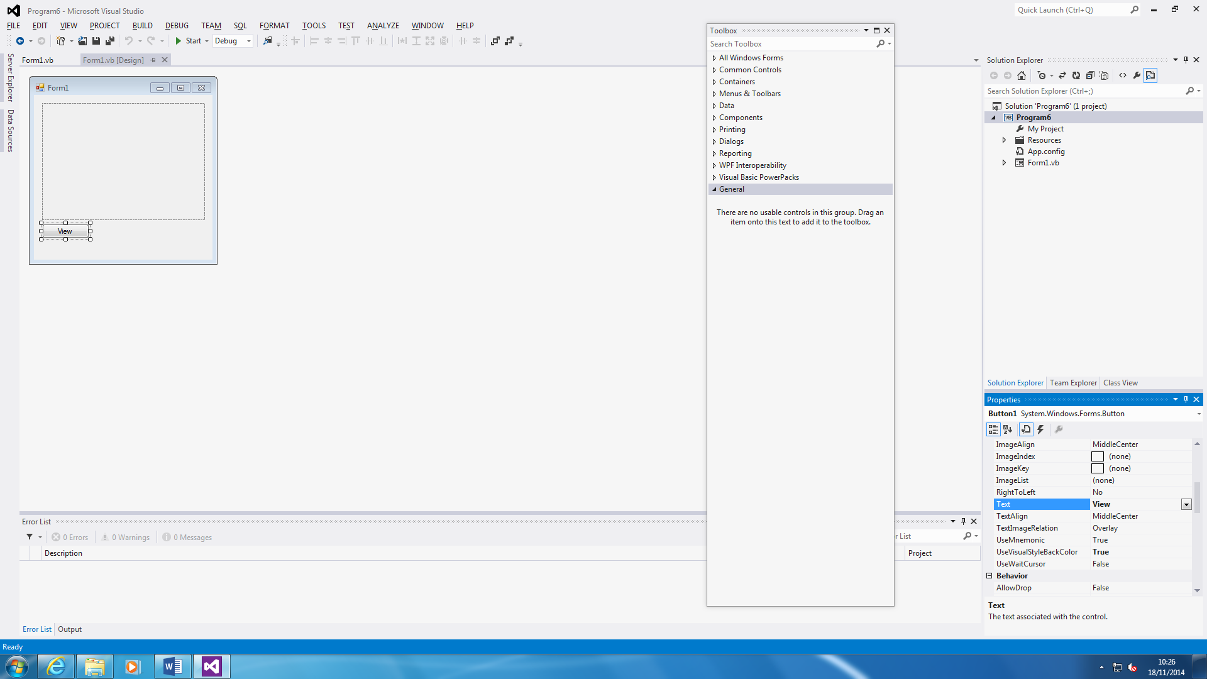**Properties**

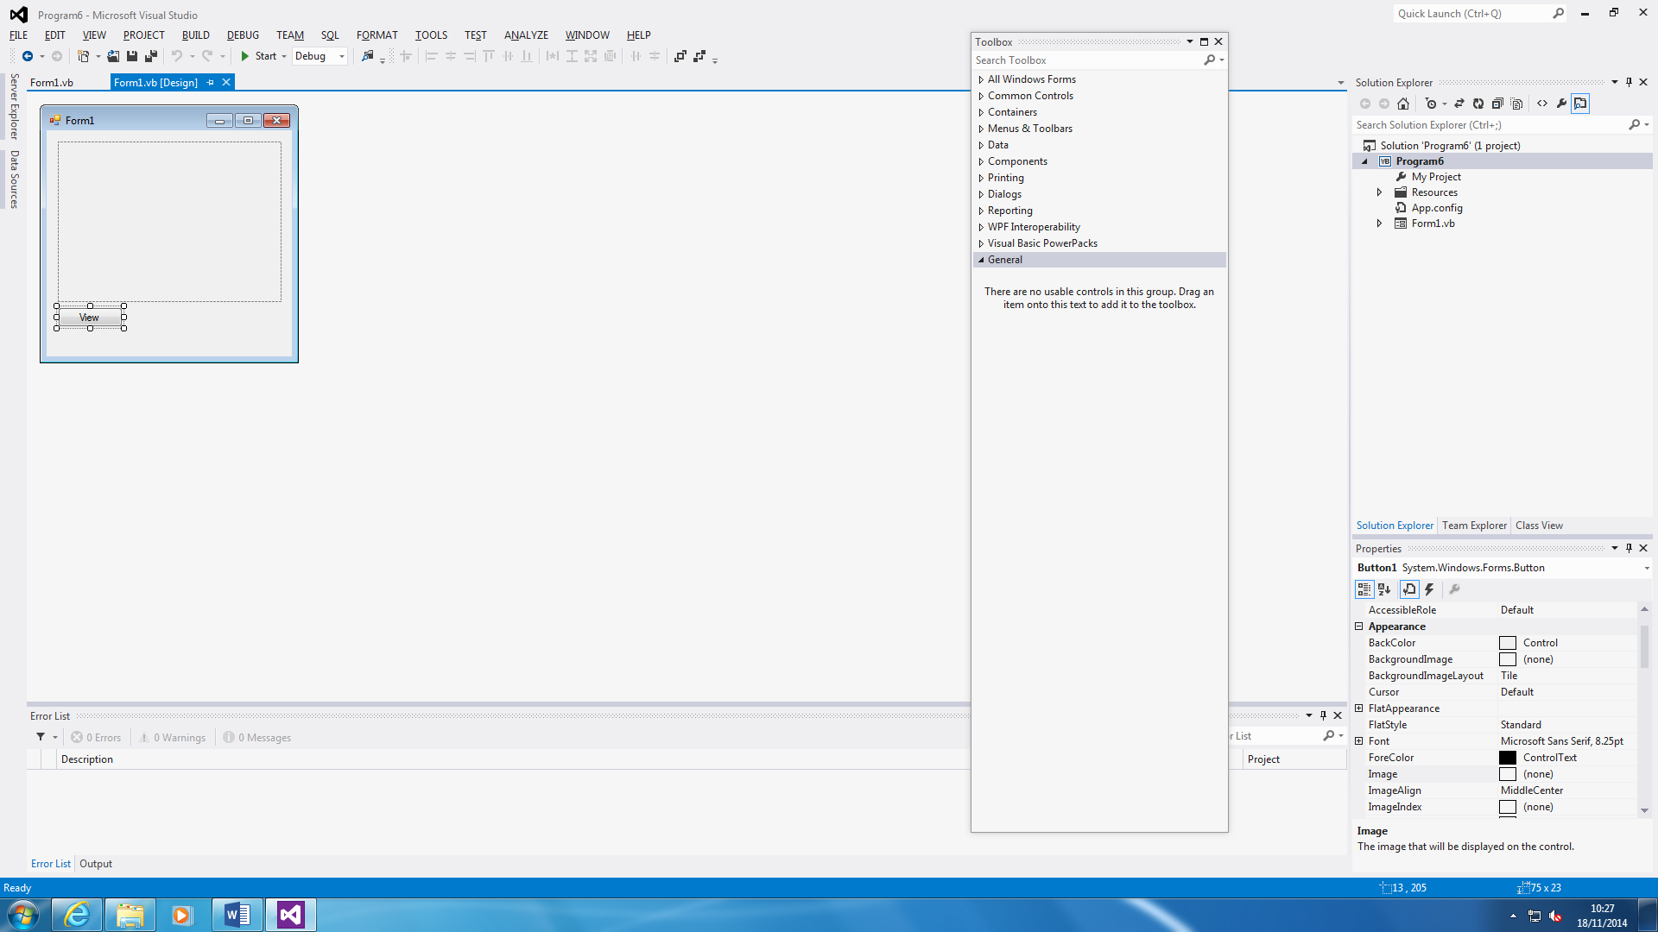

This is what I have used to for the properties. As an example, all you do is change the properties of the text. Before it was ‘Button1’ and I changed it to ‘View’ to make it realistic to what I have done for the program. You can change it to whatever text you feel like e.g. Submit or Close.

**Toolbox**

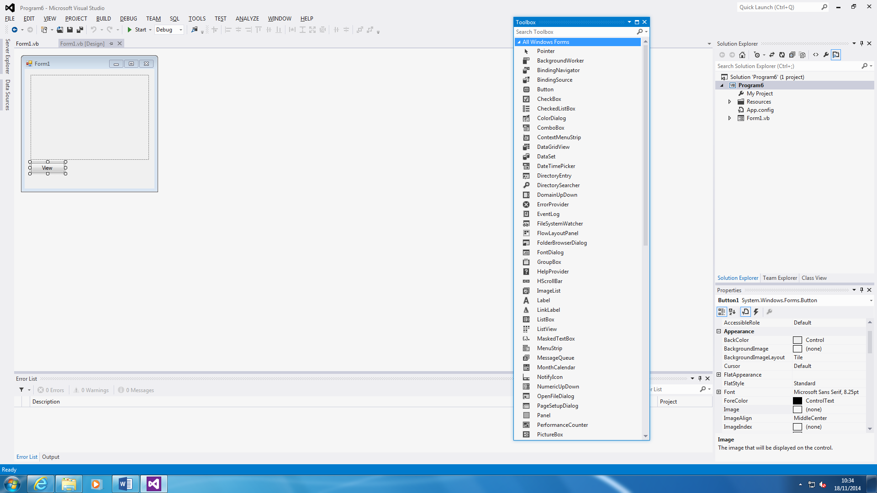

This is a Toolbox. You go there to find any tools you need to insert within your program. I have used button, progressbar, label, listbox, picturebox, textbox, and timer.